University of Primorska
Faculty of Mathematics, Natural Sciences and Information Technologies (FAMNIT)
RAVEN
Retention-Aware Verifiable Extension-block Network

PROJECT DOCUMENTATION

Author: Ekaterina Bochvaroska
Mentor: Aleksandar Tošić

Version 1.0 | May 2026

Table of Contents

Document Conventions
Symbol | Meaning
ℹ Info | Important information the reader should keep in mind.
→ Tip | Good to know — a hint that makes a task easier.
⚠ Caution | Care is required; an action here can produce incorrect or unverifiable results.

1. Problem Description

1.1 Background
Many decentralised systems separate two concerns: an ordered, append-only chain of small commitments, and the much larger payload data those commitments refer to. Keeping every full payload on every participant does not scale, so payloads are increasingly stored off-chain, with only a compact commitment recorded on-chain. This raises a data-availability and retention problem: once payloads live off-chain on nodes that each keep different amounts of history, how can a client later retrieve an arbitrary historical range and still be certain that what it receives is exactly what was originally committed?
RAVEN studies this problem in a controlled setting. Encrypted-message payloads are grouped, one group per protocol height, into off-chain extension blocks. Each extension block is committed to an ordered parent chain by a small anchor record that carries the block's cryptographic identifier. Nodes keep different retention windows: archive nodes keep everything, while regular nodes keep only a recent suffix of heights. A client that wants a range of history must gather it from several nodes and verify every piece against the chain.

1.2 The Retention and Verifiability Problem
Three difficulties make this non-trivial:
Heterogeneous retention. No single regular node can serve an arbitrarily old range. A query that reaches back beyond a node's window must be decomposed and spread across nodes that can each cover part of it, with archive nodes as a fallback.
Unreliable metadata and faults. A node may advertise more history than it actually keeps, time out, omit blocks, or return corrupted data. Retrieval must tolerate these faults and still either succeed or report the range as incomplete — it must never accept bad data.
Chain reorganisations. The ordering of commitments can change when the parent chain reorganises. Data whose only commitment ends up on an abandoned branch must be rejected, even if a node still happily serves it.

1.3 Goals of the Prototype
The project delivers a correct, modular, reproducible research prototype that evaluates:
- retention-aware query decomposition across heterogeneous nodes;
- parallel retrieval with fallback behaviour under stale or false retention metadata;
- handling of synthetic chain reorganisations;
- a fair comparison against simpler baseline retrieval strategies; and
- a demo web interface that makes the system observable and interactive for any audience.

ℹ Info. The project does not aim to build a production messaging platform or a real blockchain. A deliberately reduced parent-chain emulator stands in for a real blockchain, providing only the ordering, anchoring, finality, and reorg behaviour the retrieval layer needs.

2. System Analysis and Design

2.1 Development Methodology
The system was developed incrementally in clearly separated phases, each delivering a self-contained capability that was only considered complete once its tests passed. This kept the protocol design stable and made every increment independently verifiable.

Phase | Delivered Capability
0–1 | Repository skeleton and packaging; core data models with deterministic canonical encoding and hashing.
2 | Parent-chain emulator: hashchain blocks, anchor records, canonical-branch tracking, finality depth, and reorg injection.
3 | Node runtime: typed configuration, the FastAPI HTTP API, and seed-based peer discovery.
4 | Message mempool, write admission, extension-block production, local storage, anchoring, and retention pruning.
5 | Retention-aware query splitting, the query endpoint, sequential/parallel dispatch, and client-side validation.
6 | Shared strategy interface and the five retrieval strategies.
7 | Experiment runner, deterministic traces, load generation, and CSV metrics.
8 | Failure-injection and reorg experiments.
9 | Docker Swarm deployment, HTTP cluster experiment mode, analysis and figure generation, and the demo web interface.

Throughout, a set of standing rules guided the work: implement only the requested phase; do not redesign the protocol without recording it; keep parent-chain emulation separate from retrieval logic; keep baselines separate from the main RAVEN implementation; never silently accept invalid or missing data; and ensure every strategy runs on the same query trace.

2.2 Functional Specification

2.2.1 Actors and Roles
Two node roles and one client actor participate in the system:
- Archive nodes retain the full history of extension blocks.
- Regular nodes retain only a recent suffix window of heights.
- The client (via the demo interface or the HTTP API) submits messages, triggers block production, and retrieves and verifies ranges.
- A write-admission policy with three configurable levels (none, size_limit_only, pow_stub) controls what a node accepts into its mempool.

2.2.2 Functional Requirements
The system must:
- accept encrypted-message envelopes into a per-node mempool subject to an admission policy;
- produce one extension block per protocol height, including valid empty blocks, and commit each to the parent chain through an anchor record;
- store blocks according to each node's retention policy and prune regular nodes to their suffix window;
- decompose a query range into sub-queries matched to nodes that can cover them, with archive fallback;
- retrieve sub-queries sequentially or in parallel, retrying alternative candidates on failure;
- validate every returned block against a canonical, final anchor, classifying the outcome as Accept, Incomplete, or Reject; and
- expose all protocol operations through a demo web interface suitable for demonstration and interactive exploration.

2.2.3 Non-Functional Requirements
The prototype must be deterministic and reproducible (same seed and configuration produce the same trace and topology), simple and modular (small, typed, single-purpose modules), well tested (no phase complete without passing tests), and deployable both locally and on a Docker cluster. Correctness invariants are absolute: a corrupt block is never accepted, an orphaned anchor is never accepted, and a missing expected block is always reported as incomplete.

2.3 Modelling

2.3.1 Architectural Model
The system is layered. Each layer is a separate Python package and depends only on the layers below it:
Layer | Packages | Responsibility
Protocol core | crypto, messages, extension_blocks, parent_chain | Deterministic canonical encoding and hashing, message envelope and mempool, extension block and store, parent-chain emulator with anchor records and reorg injection.
Node runtime | node | FastAPI HTTP service with per-node state (mempool, block store, anchor index, peer table, retention policy, parent-chain view, failure mode).
Retrieval | retrieval, baselines, client | Retention-aware query splitter, sequential/parallel dispatcher, client-side validation, five retrieval strategies, and load generator.
Demo / Harness | demo_ui, experiments, metrics, analysis | Demo web interface, experiment runners, CSV metrics, and figure generation.

2.3.2 System Architecture Diagram
The diagram below illustrates the full end-to-end protocol flow across the four phases: message submission and local pools, extension-block production, parent-chain anchoring with off-chain storage, and client retrieval with cryptographic verification.

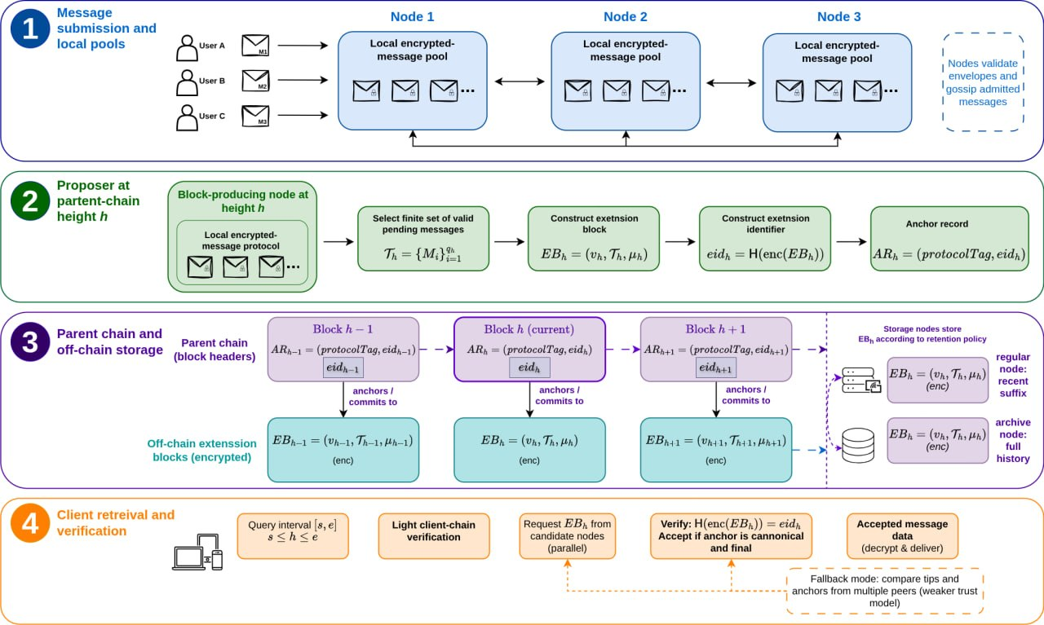
Figure 1: RAVEN system architecture — four-phase protocol flow.

2.3.3 Protocol and Data Model
The protocol follows a one-extension-block-per-height model. The central objects are:
- EncryptedMessageEnvelope — an opaque encrypted message payload awaiting inclusion;
- ExtensionBlock — the off-chain data object for one protocol height, whose canonical SHA-256 hash is its extension identifier (eid_h);
- AnchorRecord — the parent-chain commitment, binding a height to an eid;
- ParentChainBlock — a block in the hashchain emulator carrying an optional AnchorRecord; and
- NodeInfo, QueryInterval, SubQueryAssignment — node and query types used by the retrieval layer.

ℹ Info. The parent-chain block points to the extension block through eid_h, but the extension block does not point back at the chain block. This one-directional link makes reorganisation handling simpler: an extension block can be re-bound to a new canonical block without being rebuilt.

2.3.4 Process Models
Three workflows were modelled explicitly:
Write / production. A client submits messages; a proposer greedily admits pending messages up to the size limit, builds the extension block, computes its identifier (eid_h = SHA-256 of canonical encoding), appends a parent-chain block with the anchor record, and stores the block.
Query / retrieval. A range [s, e] is split right-to-left into segments whenever the set of covering nodes changes; adjacent identical segments are merged; candidates are tried with bounded timeouts and retries; and each returned block is validated against its canonical, final anchor.
Reorg handling. When the canonical branch switches, anchors on the abandoned branch become Orphaned; validation rejects any block whose only anchor is orphaned, and re-binds blocks whose eid reappears on the new branch once it is final.

The retrieval validation outcome is modelled as three exclusive states:
Outcome | When It Is Returned
Accept | Every height in the range has a canonical, final anchor and a returned block whose identifier matches it.
Incomplete | An expected block or anchor is simply missing — not corrupt.
Reject | Data is invalid, corrupt, fraudulent, duplicated, non-canonical, not yet final, or anchored only in an orphaned block.

3. Implementation

3.1 Selected Tools
Tool | Role in the Project
Python 3.11+ | Primary implementation language for all protocol, node, retrieval, and experiment code.
FastAPI | Node HTTP API — a stable JSON interface for every protocol operation.
uvicorn | ASGI server that runs each node process.
httpx | Async HTTP client for the dispatcher and load generator, including in-process transports used by tests.
dataclasses (stdlib) | Typed, immutable protocol objects with validation — pydantic intentionally avoided to keep the core dependency-light.
matplotlib | Generation of paper-ready figures from result files.
pytest | Unit and integration tests (over 160 in total).
Docker / Docker Compose | Containerisation and local multi-node deployment from a single image.
HTML / CSS / JavaScript | Demo web interface (single-page application, no external framework).

ℹ Info. pandas is used only for offline result summarisation in the analysis scripts, never in the core runtime. The analysis scripts only ever read result files and never modify raw outputs.

3.2 Implementation Approaches

3.2.1 Deterministic Canonical Encoding
Because the whole protocol rests on hashes matching, every hashed object is serialised through one canonical encoder: sorted string keys, ASCII output, no insignificant whitespace, explicit type tags for bytes and sets, field-sorted dataclasses, and an outright ban on floats. Identical contents therefore always produce identical bytes and the same lowercase SHA-256 hex identifier. This is the single most important design decision in the codebase.
⚠ Caution. Never hash a Python repr or a non-deterministic JSON dump. Every protocol object exposes a stable to_canonical_bytes() method built on the canonical encoder.

3.2.2 The Parent-Chain Emulator
Rather than integrate a real blockchain, a deterministic hashchain emulator provides ordered, anchor-bearing blocks, canonical-branch tracking, a configurable confirmation depth for finality, and deterministic fork injection. Keeping it separate from the retrieval logic means precise reorgs and finality conditions can be injected without touching the protocol code under evaluation.

3.2.3 Retention-Aware Decomposition and Validated Dispatch
The retrieval approach uses a greedy right-to-left splitter that opens a new sub-query only when the set of covering nodes changes, followed by a dispatcher that tries candidates with bounded timeouts and retries the next candidate on any failure. Retrieval and trust are separated: a node's answer is only ever accepted after independent client-side validation against a canonical, final anchor, so a faulty or dishonest node cannot cause bad data to be accepted.

3.2.4 Retrieval Strategies
Five retrieval strategies are implemented, all sharing one interface and running on the same generated query trace:
Strategy | Behaviour
archive_only_rr | Sends every query to archive nodes only, round-robin. Full-coverage baseline.
naive_whole_range | Retrieves the whole interval from a single node whose advertised window covers it, falling back to archives. Retention-aware selection without decomposition.
raven_sequential | RAVEN decomposition with sequential sub-query retrieval. Isolates the value of parallel dispatch.
raven_parallel | Full RAVEN — retention-aware decomposition with parallel dispatch. Primary strategy.
fixed_chunk | Splits into fixed-size chunks retrieved in parallel. Contrasts retention-aware splitting with naive chunking.

3.2.5 Demo Web Interface
A single-page web application exposes every core protocol operation through a browser — message submission, block production, range queries, node inspection, and live failure-mode control — without requiring command-line knowledge. It communicates directly with the node HTTP API; no additional backend is required. The demo is served alongside the node containers in the Docker Compose setup.

3.2.6 Deployment Architecture
The same Docker image runs as a seed node, regular node, archive node, or demo client, depending on environment variables. A local Docker Compose file starts one seed, two regular nodes, one archive node, and the demo interface for development and demonstration use.

4. Conclusion
The RAVEN project delivered a complete, modular, and reproducible research prototype of a retention-aware verifiable extension-block network. The delivered system includes:
- a deterministic canonical encoding and hashing scheme that underpins all protocol correctness guarantees;
- a parent-chain emulator providing ordering, anchoring, finality, and reorg behaviour without a real blockchain;
- a node runtime with a complete HTTP API, configurable retention policies, and injectable failure modes;
- a retention-aware retrieval pipeline with parallel dispatch and client-side validation against canonical, final anchors;
- five retrieval strategies sharing one interface and running on the same query trace for fair comparison;
- over 160 unit and integration tests with correctness invariants verified at every level; and
- a demo web interface that makes all protocol operations accessible and observable to any audience.

Correctness invariants are absolute and enforced throughout: corrupt blocks are rejected, missing blocks are reported as incomplete, and orphaned anchors are rejected after reorgs. The implementation is intentionally modular so that it can be extended — with additional strategies, retention distributions, or failure scenarios — without disturbing the protocol core, positioning the prototype well for further research and evaluation.

End of Project Documentation
RAVEN / Research Prototype 2026 | Ekaterina Bochvaroska | Mentor: Aleksandar Tošić | Version 1.0

